Rockbuster Stealth LLC

Data dictionary

Kasun daundasekara

2024

Table of Contents

Data Storage & Structure**2**

Fact Tables. **3**

Payment 3

Rental3

Dimension Tables**3**

film_actor3

inventory4

actor 4

language4

film_category5

category5

customer5

store6

staff6

address7

city7

country7

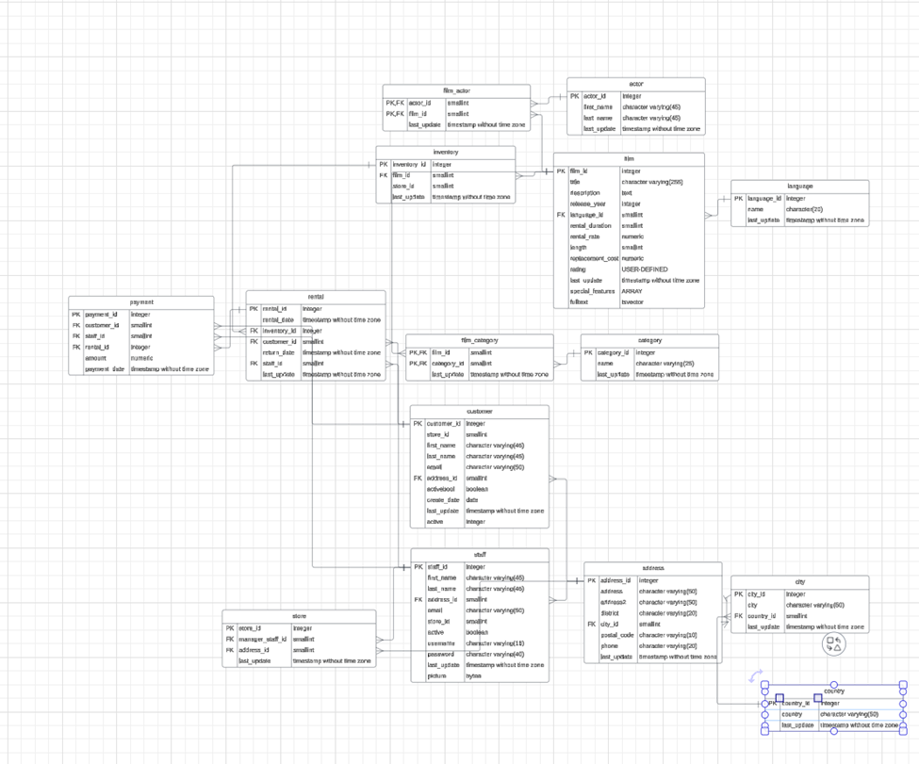

Fact Tables.

Payment

|  |  |  |
| --- | --- | --- |
| Column | Type | Description |
| payment_id | Integer | Unique identifier for each payment record. |
| customer_id | SmallInt | Links to the customer table. |
| staff_id | SmallInt | Links to the staff table. |
| rental_id | Integer | Links to the rental table. |
| amount | Numeric | Payment amount. |
| payment_date | Timestamp (no time zone) | Date and time of payment. |

Rental

|  |  |  |
| --- | --- | --- |
| Column | Type | Description |
| rental_id | Integer | Unique identifier for each rental record. |
| rental_date | Timestamp (no time zone) | Date and time the rental started. |
| inventory_id | Integer | Links to the inventory table. |
| customer_id | SmallInt | Links to the customer table. |
| return_date | Timestamp (no time zone) | Date and time the rental was returned. |
| staff_id | SmallInt | Links to the staff table. |
| last_update | Timestamp (no time zone) | Last update to this record. |

Dimension Tables.

Film Actor

|  |  |  |
| --- | --- | --- |
| Column | Type | Description |
| actor_id | SmallInt | Links to the actor table (PK, FK). |
| film_id | SmallInt | Links to the film table (PK, FK). |
| last_update | Timestamp (no time zone) | Last update to this record. |

Inventory

|  |  |  |
| --- | --- | --- |
| Column | Type | Description |
| inventory_id | Integer | Unique identifier for each inventory record. |
| film_id | SmallInt | Links to the film table. |
| store_id | SmallInt | Identifies the store holding the inventory. |
| last_update | Timestamp (no time zone) | Last update to this record. |

Actor

|  |  |  |
| --- | --- | --- |
| Column | Type | Description |
| actor_id | Integer | Unique identifier for each actor record. |
| first_name | Character Varying(45) | Actor's first name. |
| last_name | Character Varying(45) | Actor's last name. |
| last_update | Timestamp (no time zone) | Last update to this record. |

Film

|  |  |  |
| --- | --- | --- |
| Column | Type | Description |
| film_id | Integer | Unique identifier for each film record. |
| title | Character Varying(255) | The title of the film. |
| description | Text | A description of the film. |
| release_year | Integer | The year the film was released. |
| language_id | SmallInt | Links to the language table. |
| rental_duration | SmallInt | The duration in days for which the film can be rented. |
| rental_rate | Numeric | The cost to rent the film. |
| length | SmallInt | The length of the film in minutes. |
| replacement_cost | Numeric | Cost to replace the film. |
| rating | USER-DEFINED | The film's rating. |
| last_update | Timestamp (no time zone) | Last update to this record. |
| special_features | ARRAY | An array of special features of the film. |
| fulltext | tsvector | Text search vector for the film. |

Language

|  |  |  |
| --- | --- | --- |
| Column | Type | Description |
| language_id | Integer | Unique identifier for each language record. |
| name | Character(20) | The name of the language. |
| last_update | Timestamp (no time zone) | Last update to this record. |

Film category.

|  |  |  |
| --- | --- | --- |
| Column | Type | Description |
| film_id | SmallInt | Links to the film table (PK, FK). |
| category_id | SmallInt | Links to the category table (PK, FK). |
| last_update | Timestamp (no time zone) | Last update to this record. |

Category

|  |  |  |
| --- | --- | --- |
| Column | Type | Description |
| category_id | Integer | Unique identifier for each category. |
| name | Character Varying(25) | The name of the category. |
| last_update | Timestamp (no time zone) | Last update to this record. |

Customer

|  |  |  |
| --- | --- | --- |
| Column | Type | Description |
| customer_id | Integer | Unique identifier for each customer record. |
| store_id | SmallInt | Identifies the store associated with the customer. |
| first_name | Character Varying(45) | The customer's first name. |
| last_name | Character Varying(45) | The customer's last name. |
| email | Character Varying(50) | The customer's email address. |
| address_id | SmallInt | Links to the address table (FK). |
| activebool | Boolean | A boolean flag indicating active status. |
| create_date | Date | The date the customer record was created. |
| last_update | Timestamp (no time zone) | Last update to this record. |
| active | Integer | An integer flag indicating active status (alternative to activebool). |

Store

|  |  |  |
| --- | --- | --- |
| Column | Type | Description |
| store_id | Integer | Unique identifier for each store record. |
| manager_staff_id | SmallInt | Links to a staff member designated as the manager (FK). |
| address_id | SmallInt | Links to the address table (FK). |
| last_update | Timestamp (no time zone) | Last update to this record. |

Staff

|  |  |  |
| --- | --- | --- |
| Column | Type | Description |
| staff_id | Integer | Unique identifier for each staff record. |
| first_name | Character Varying(45) | The staff member's first name. |
| last_name | Character Varying(45) | The staff member's last name. |
| address_id | SmallInt | Links to the address table (FK). |
| email | Character Varying(50) | The staff member's email address. |
| store_id | SmallInt | Identifies the store associated with the staff member. |
| active | Boolean | A boolean flag indicating active status. |
| username | Character Varying(16) | The staff member's username. |
| password | Character Varying(40) | The staff member's password. |
| last_update | Timestamp (no time zone) | Last update to this record. |
| picture | Bytea | A binary field for storing staff pictures. |

Address

|  |  |  |
| --- | --- | --- |
| Column | Type | Description |
| address_id | Integer | Unique identifier for each address record. |
| address | Character Varying(50) | The primary address line. |
| address2 | Character Varying(50) | The secondary address line (optional). |
| district | Character Varying(20) | The district or area of the address. |
| city_id | SmallInt | Links to the city table (FK). |
| postal_code | Character Varying(10) | The postal or ZIP code of the address. |
| phone | Character Varying(20) | The primary contact phone number. |
| last_update | Timestamp (no time zone) | Last update to this record. |

City

|  |  |  |
| --- | --- | --- |
| Column | Type | Description |
| city_id | Integer | Unique identifier for each city record. |
| city | Character Varying(50) | The name of the city. |
| country_id | SmallInt | Links to the country table (FK). |
| last_update | Timestamp (no time zone) | Last update to this record. |

Country

|  |  |  |
| --- | --- | --- |
| Column | Type | Description |
| country_id | Integer | Unique identifier for each country record. |
| country | Character Varying(50) | The name of the country. |
| last_update | Timestamp (no time zone) | Last update to this record. |